Routing Policy

🌐 What Is an Routing Policy?
# Source: Chatgpt (GPT‑5 Mini) at [12/15/2025]
A routing policy is a set of rules and preferences that control how routers select, accept, advertise, or prioritize routes between networks — especially between Autonomous Systems (AS) using BGP (Border Gateway Protocol).

🧠 Simple Definition:
# Source: Chatgpt (GPT‑5 Mini) at [12/15/2025]
A routing policy defines how traffic enters, leaves, or flows through a network, based on business goals, technical rules, or security requirements.

🎯 Purpose of Routing Policies
# Source: Chatgpt (GPT‑5 Mini) at [12/15/2025]
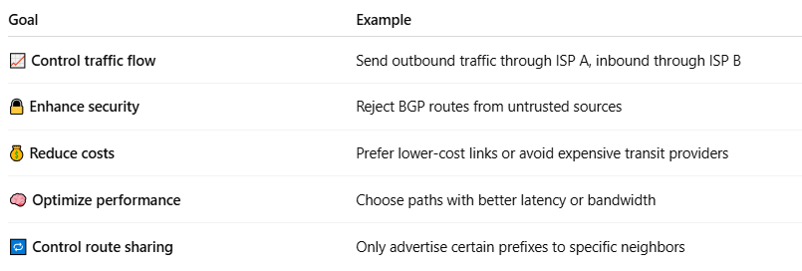
Goal | Example
📈 Control traffic flow | Send outbound traffic through ISP A, inbound through ISP B
🔒 Enhance security | Reject BGP routes from untrusted sources
💰 Reduce costs | Prefer lower-cost links or avoid expensive transit providers
🧠 Optimize performance | Choose paths with better latency or bandwidth
🔁 Control route sharing | Only advertise certain prefixes to specific neighbors

🔧 Key Tools Used in Routing Policies
# Source: Chatgpt (GPT‑5 Mini) at [12/15/2025]
Routing policies in BGP and other protocols are implemented using:
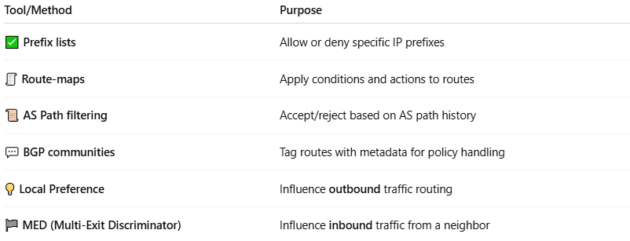
Tool/Method | Purpose
✅ Prefix lists | Allow or deny specific IP prefixes
🧾 Route-maps | Apply conditions and actions to routes
📜 AS Path filtering | Accept/reject based on AS path history
💬 BGP communities | Tag routes with metadata for policy handling
💡 Local Preference | Influence outbound traffic routing
🏁 MED (Multi-Exit Discriminator) | Influence inbound traffic from a neighbor

🔄 Example Routing Policy (BGP)
# Source: Chatgpt (GPT‑5 Mini) at [12/15/2025]
🎯 Goal: Prefer ISP1 for outbound traffic, but use ISP2 for backup.

Configuration:
# Source: Chatgpt (GPT‑5 Mini) at [12/15/2025]
- Set Local Preference = 200 for routes learned from ISP1
- Set Local Preference = 100 for ISP2
→ Routers will prefer ISP1 due to higher local pref.

🏢 Real-World Use Cases
# Source: Chatgpt (GPT‑5 Mini) at [12/15/2025]
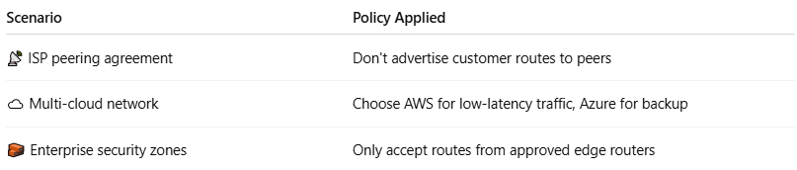

Scenario | Policy Applied
📡 ISP peering agreement | Don't advertise customer routes to peers
☁️ Multi-cloud network | Choose AWS for low-latency traffic, Azure for backup
🧱 Enterprise security zones | Only accept routes from approved edge routers

✅ Summary
# Source: Chatgpt (GPT‑5 Mini) at [12/15/2025]
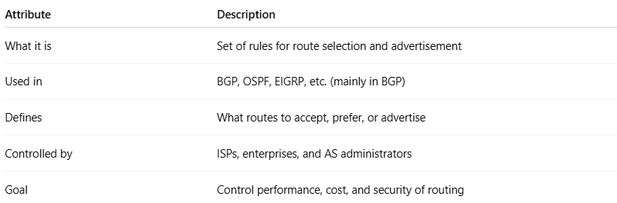

Attribute | Description
What it is | Set of rules for route selection and advertisement
Used in | BGP, OSPF, EIGRP, etc. (mainly in BGP)
Defines | What routes to accept, prefer, or advertise
Controlled by | ISPs, enterprises, and AS administrators
Goal | Control performance, cost, and security of routing

